Using Device : cpu
Dataset
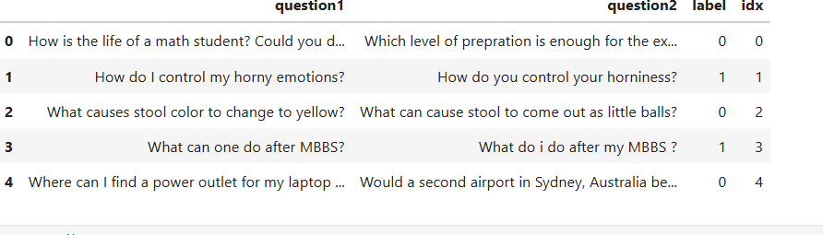

Data Shape: (363846, 4)

<class 'pandas.DataFrame'>
RangeIndex: 363846 entries, 0 to 363845

Data columns (total 4 columns):
# Column Non-Null Count Dtype
--- ------ -------------- -----
0 question1 363846 non-null str
1 question2 363846 non-null str
2 label 363846 non-null int64
3 idx 363846 non-null int32
dtypes: int32(1), int64(1), str(2)
memory usage: 51.3 MB

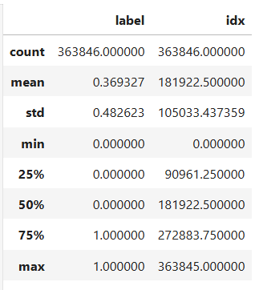
Columns:
['question1', 'question2', 'label', 'idx']

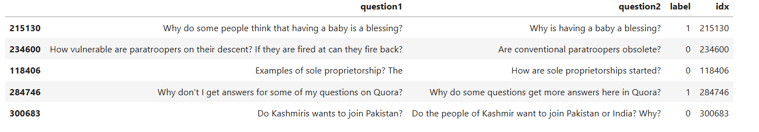
Missing Values
--------------------------------------------------
question1 0
question2 0
label 0
idx 0
dtype: int64

Missing Count Missing Percentage
question1 0 0.0
question2 0 0.0
label 0 0.0
idx 0 0.0

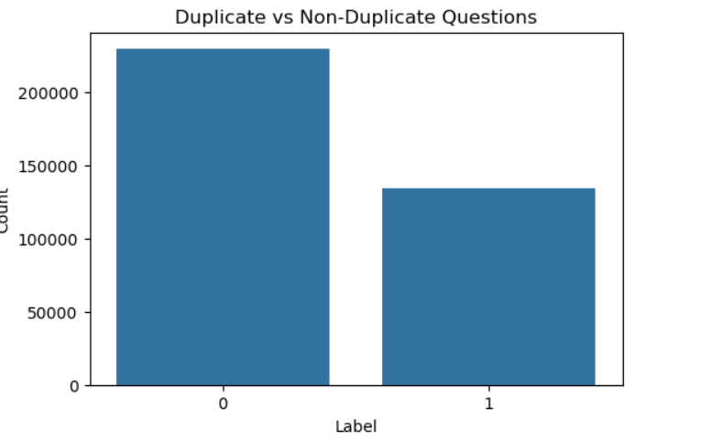

Question1 Word Count
count 363846.000000
mean 10.942822
std 5.437638
min 1.000000
25% 7.000000
50% 10.000000
75% 13.000000
max 125.000000
Name: q1_word_count, dtype: float64

Question2 Word Count
count 363846.000000
mean 11.183468
std 6.325961
min 1.000000
25% 7.000000
50% 10.000000
75% 13.000000
max 237.000000
Name: q2_word_count, dtype: float64

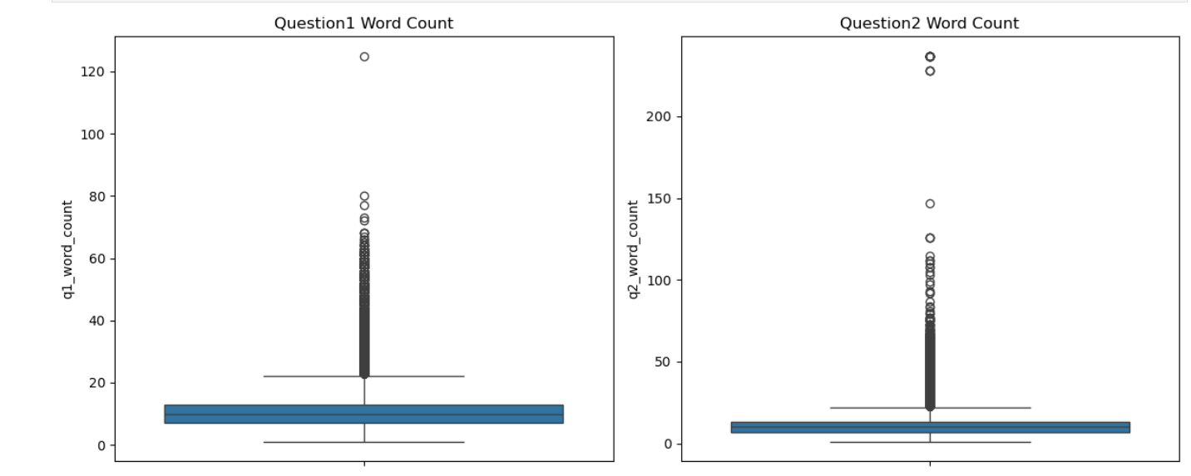

label
0 63.067342
1 36.932658
Name: proportion, dtype: float64

PREPROCESSING
Original
How is the life of a math student? Could you describe your own experiences?

After Lowercase
how is the life of a math student? could you describe your own experiences?

After Punctuation Removal
how is the life of a math student could you describe your own experiences

After Tokenization
['how', 'is', 'the', 'life', 'of', 'a', 'math', 'student', 'could', 'you', 'describe', 'your', 'own', 'experiences']

After Stopword Removal
['life', 'math', 'student', 'could', 'describe', 'experiences']

After Lemmatization
['life', 'math', 'student', 'could', 'describe', 'experience']

Final Output
life math student could describe experience

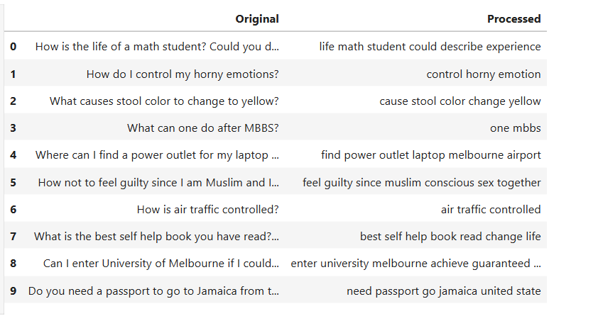

FEATURE ENGINEERING
Q1 TF-IDF Shape : (363846, 10000)
Q2 TF-IDF Shape : (363846, 10000)

Vocabulary Size : 10000
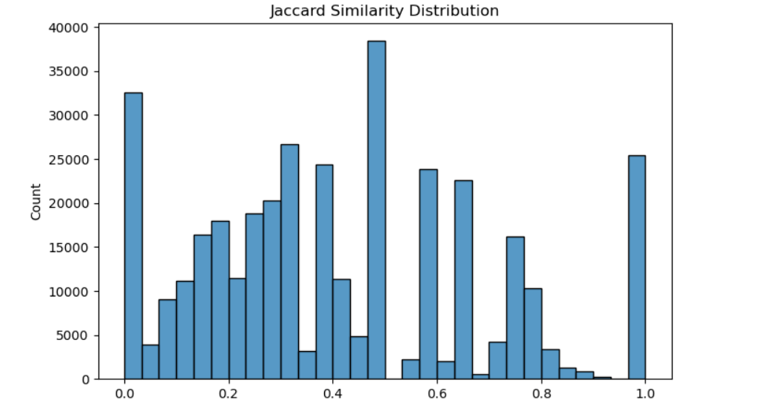

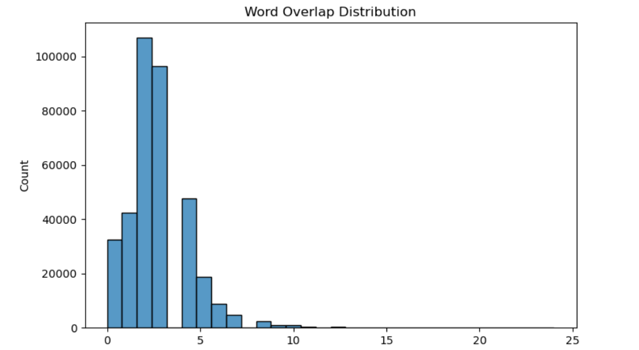

Train Test Split
X-Train: (291076, 20004)
Y-Train: (291076,)
X-Test: (72770, 20004)
Y-Test: (72770,)

CLASS MODELS
LogisticRegression
LogisticRegression(max_iter=1000)

LinearSVC
LinearSVC()

MultinomialNB
MultinomialNB()

XGBClassifier
XGBClassifier(base_score=None, booster=None, callbacks=None,
colsample_bylevel=None, colsample_bynode=None,
colsample_bytree=None, device=None, early_stopping_rounds=None,
enable_categorical=False, eval_metric=None, feature_types=None,
feature_weights=None, gamma=None, grow_policy=None,
importance_type=None, interaction_constraints=None,
learning_rate=None, max_bin=None, max_cat_threshold=None,
max_cat_to_onehot=None, max_delta_step=None, max_depth=None,
max_leaves=None, min_child_weight=None, missing=nan,
monotone_constraints=None, multi_strategy=None, n_estimators=None,
n_jobs=None, num_parallel_tree=None, ...)

RandomForestClassifier
RandomForestClassifier(max_depth=10, n_estimators=10, n_jobs=-1,
random_state=42)

========== MODEL COMPARISON ==========

Model Accuracy Precision Recall F1 Score
1 Linear SVM 0.787564 0.676532 0.813998 0.738926
3 XGBoost 0.786986 0.701620 0.736419 0.718599
4 Sentence-BERT 0.781902 0.681907 0.767488 0.722171
0 Logistic Regression 0.752783 0.633032 0.786650 0.701530
2 Random Forest 0.750144 0.722376 0.525413 0.608349

========== BEST MODEL ==========

Model : Linear SVM
Accuracy : 0.7876
Precision : 0.6765
Recall : 0.814
F1 Score : 0.7389

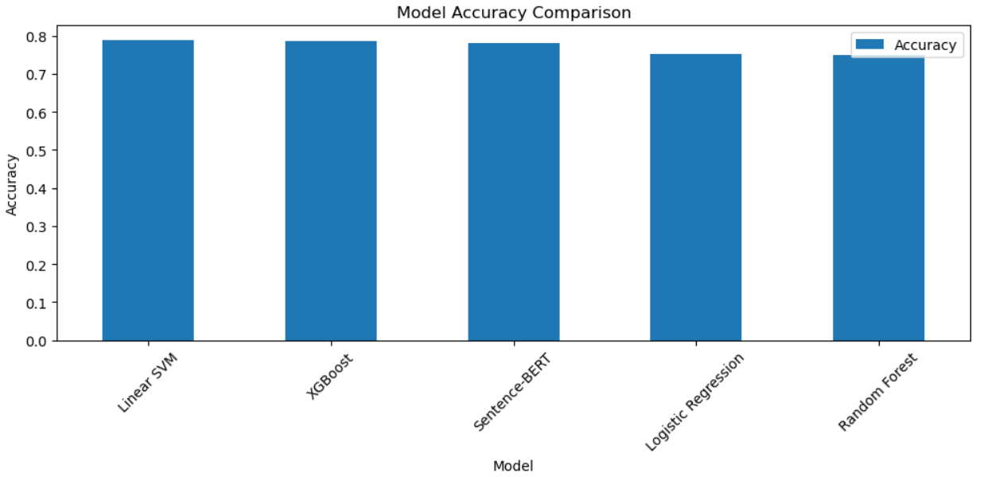

======================================================================
QQP DUPLICATE QUESTION DETECTION SYSTEM
======================================================================
Enter Question 1 : How can I learn Python?
Enter Question 2 : What is the best way to learn Python?

Runtime Feature Shape : (1, 10013)
Model Expected Shape : 10013

RESULT
----------------------------------------------------------------------
DUPLICATE QUESTION
Both questions have similar meaning.
----------------------------------------------------------------------

Do you want to test another pair? (y/n): y
Enter Question 1 : How can I learn Python?
Enter Question 2 : Who won the FIFA World Cup?

Runtime Feature Shape : (1, 10013)
Model Expected Shape : 10013

RESULT
----------------------------------------------------------------------
NOT DUPLICATE
Questions have different meanings.
----------------------------------------------------------------------

Do you want to test another pair? (y/n): n

System Closed Successfully.

